Program Structures and Algorithms

Spring 2023 (SEC—8)

NAME – Abhinav Ankur

NUID – 002747605

**Task** – ***In this assignment, your task is to determine--for sorting algorithms--what is the best predictor of total execution time: comparisons, swaps/copies, hits (array accesses), or something else. You will run the benchmarks for merge sort, (dual-pivot) quick sort, and heap sort. You will sort randomly generated arrays of between 10,000 and 256,000 elements (doubling the size each time). If you use the SortBenchmark, as I expect, the number of runs is chosen for you. So, you can ignore the instructions about setting the number of runs. For each experiment (a sort method of a given size), you will run it twice: once for the instrumentation, once (without instrumentation) for the timing***

**Code –**

**Heap Sort**

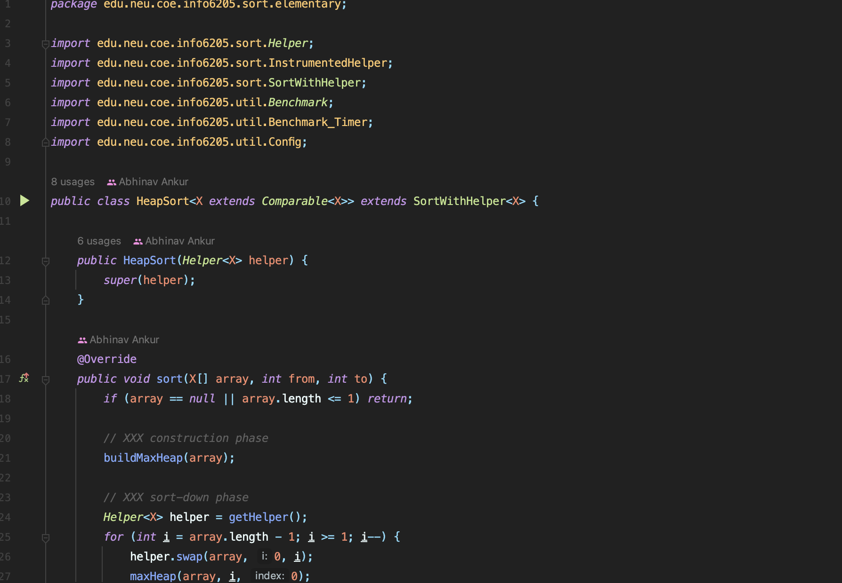

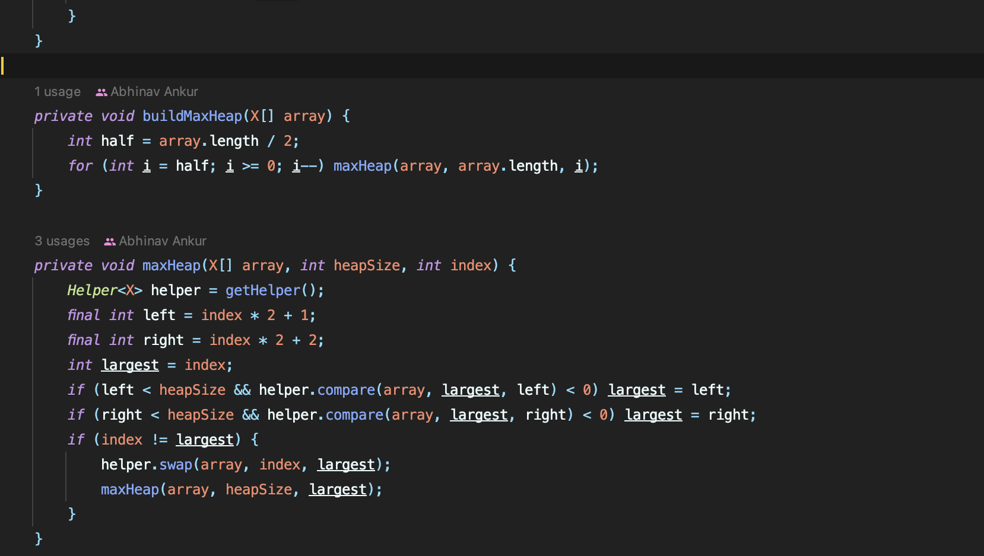

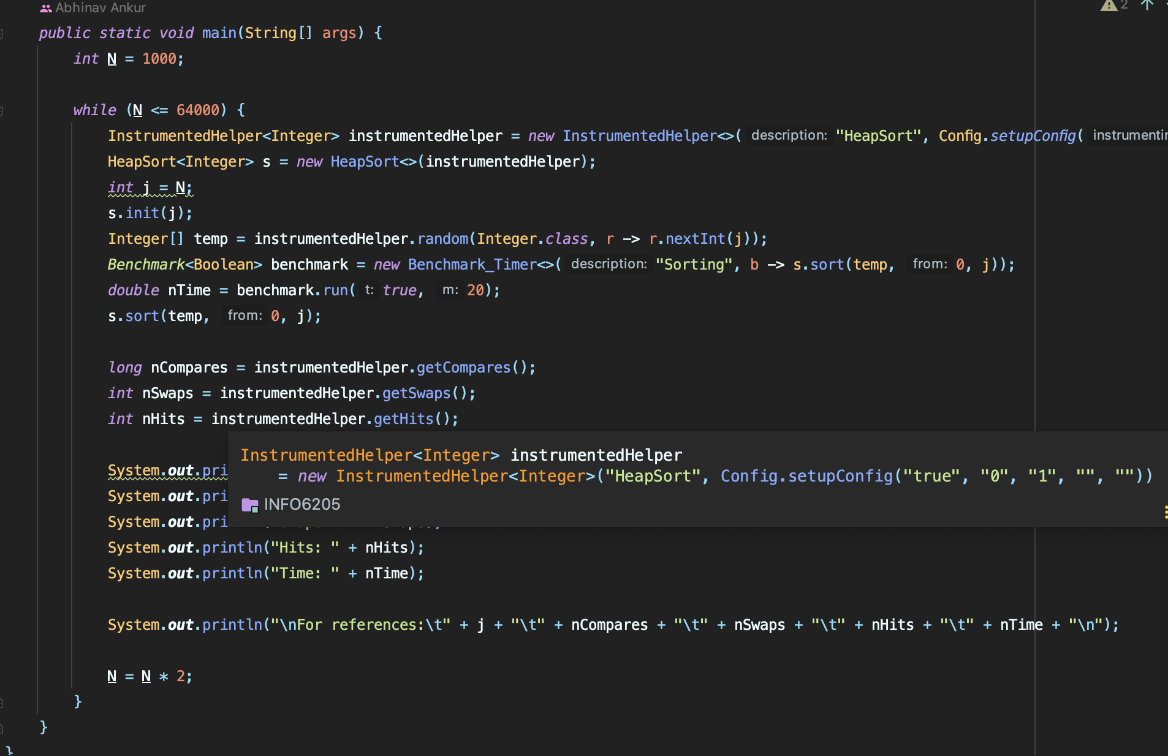

**Test cases for heap sort**

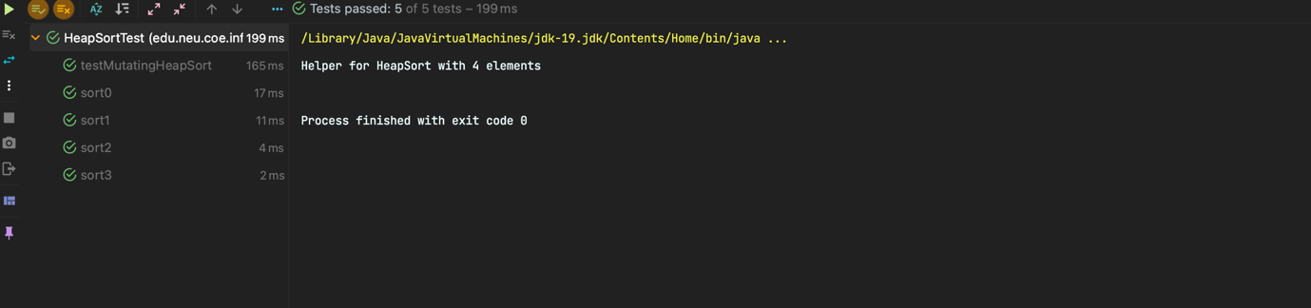

**Merge Sort**

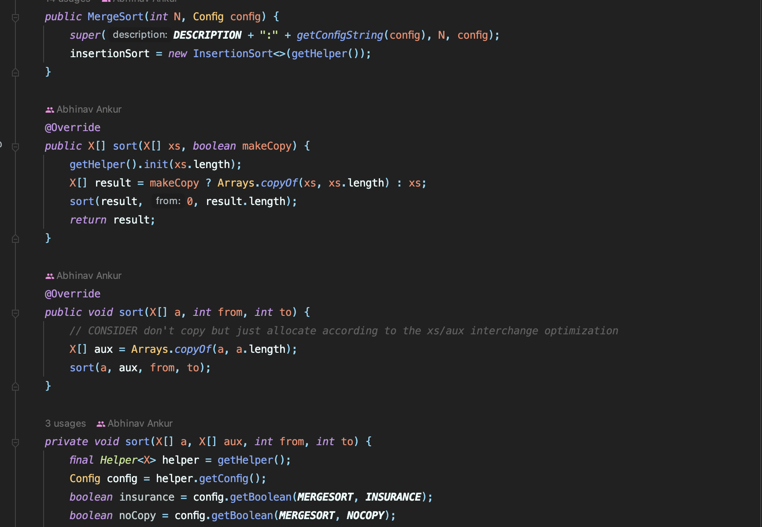

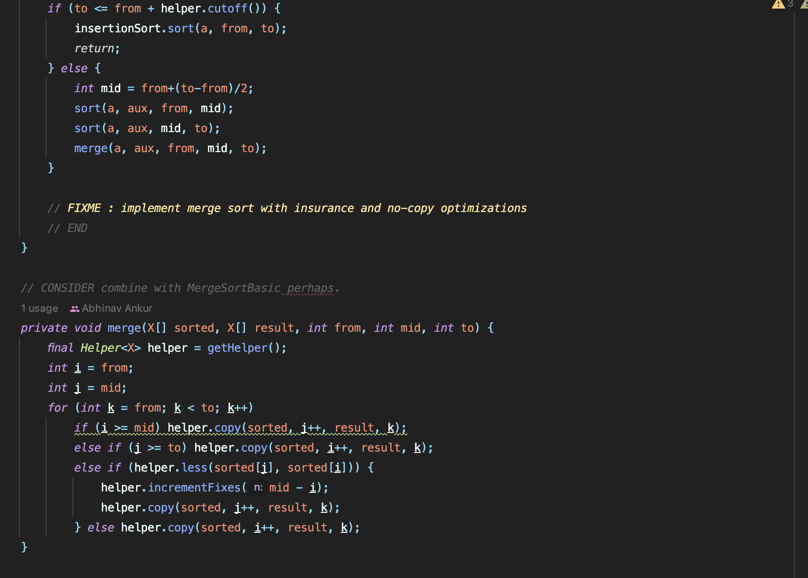

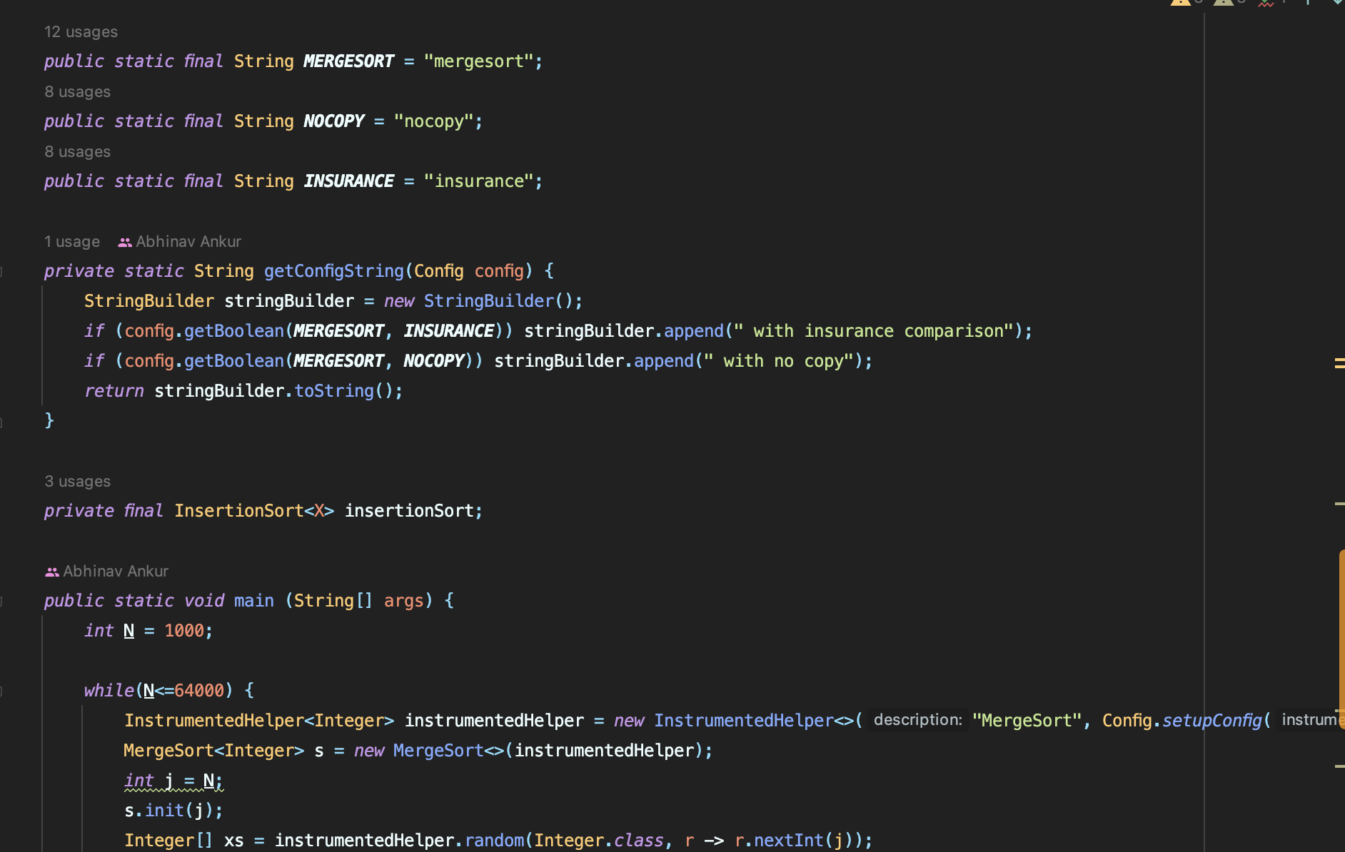

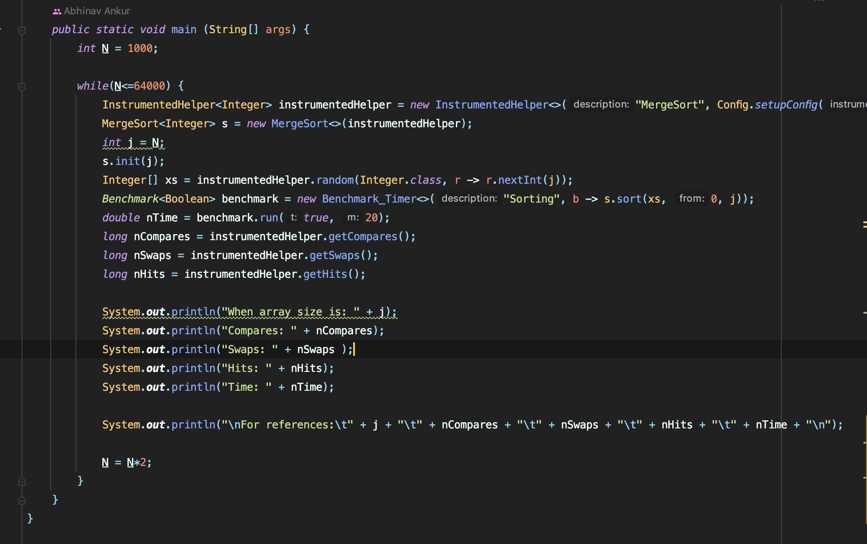

**QuickSort-DualPiivot**

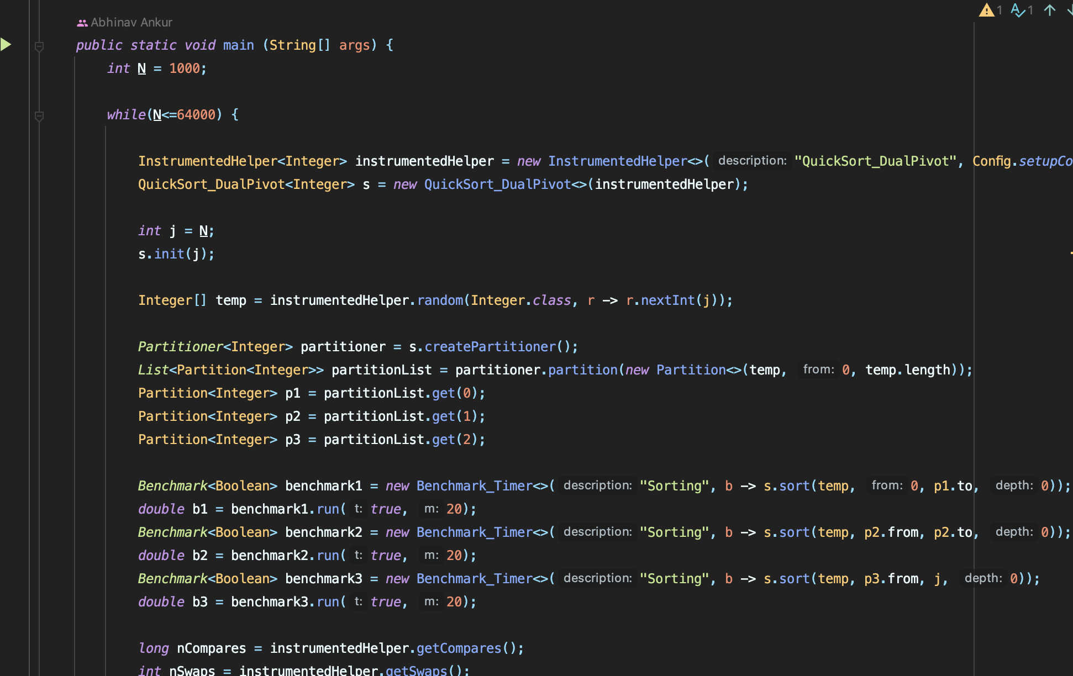

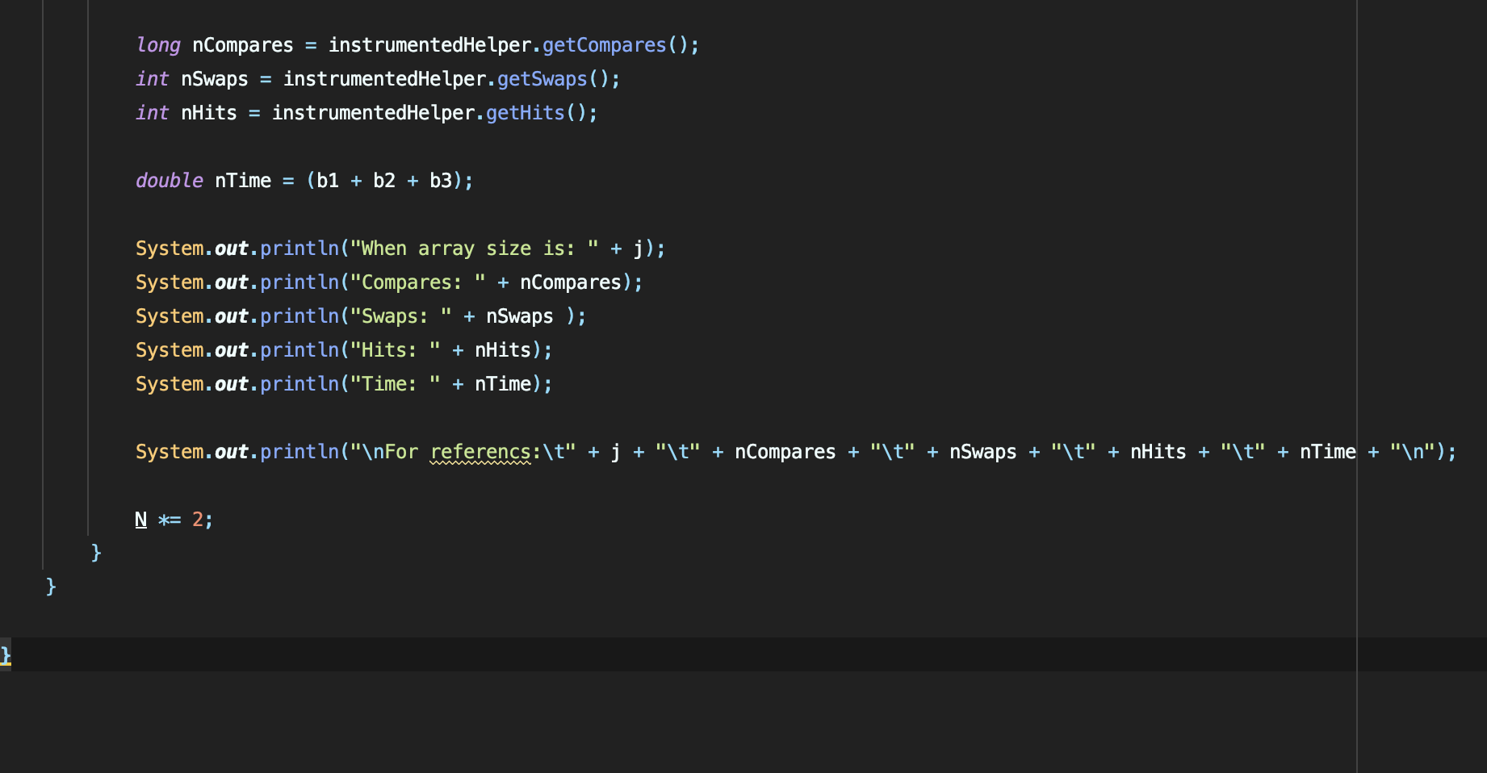

**Output –**

**Heap sort**

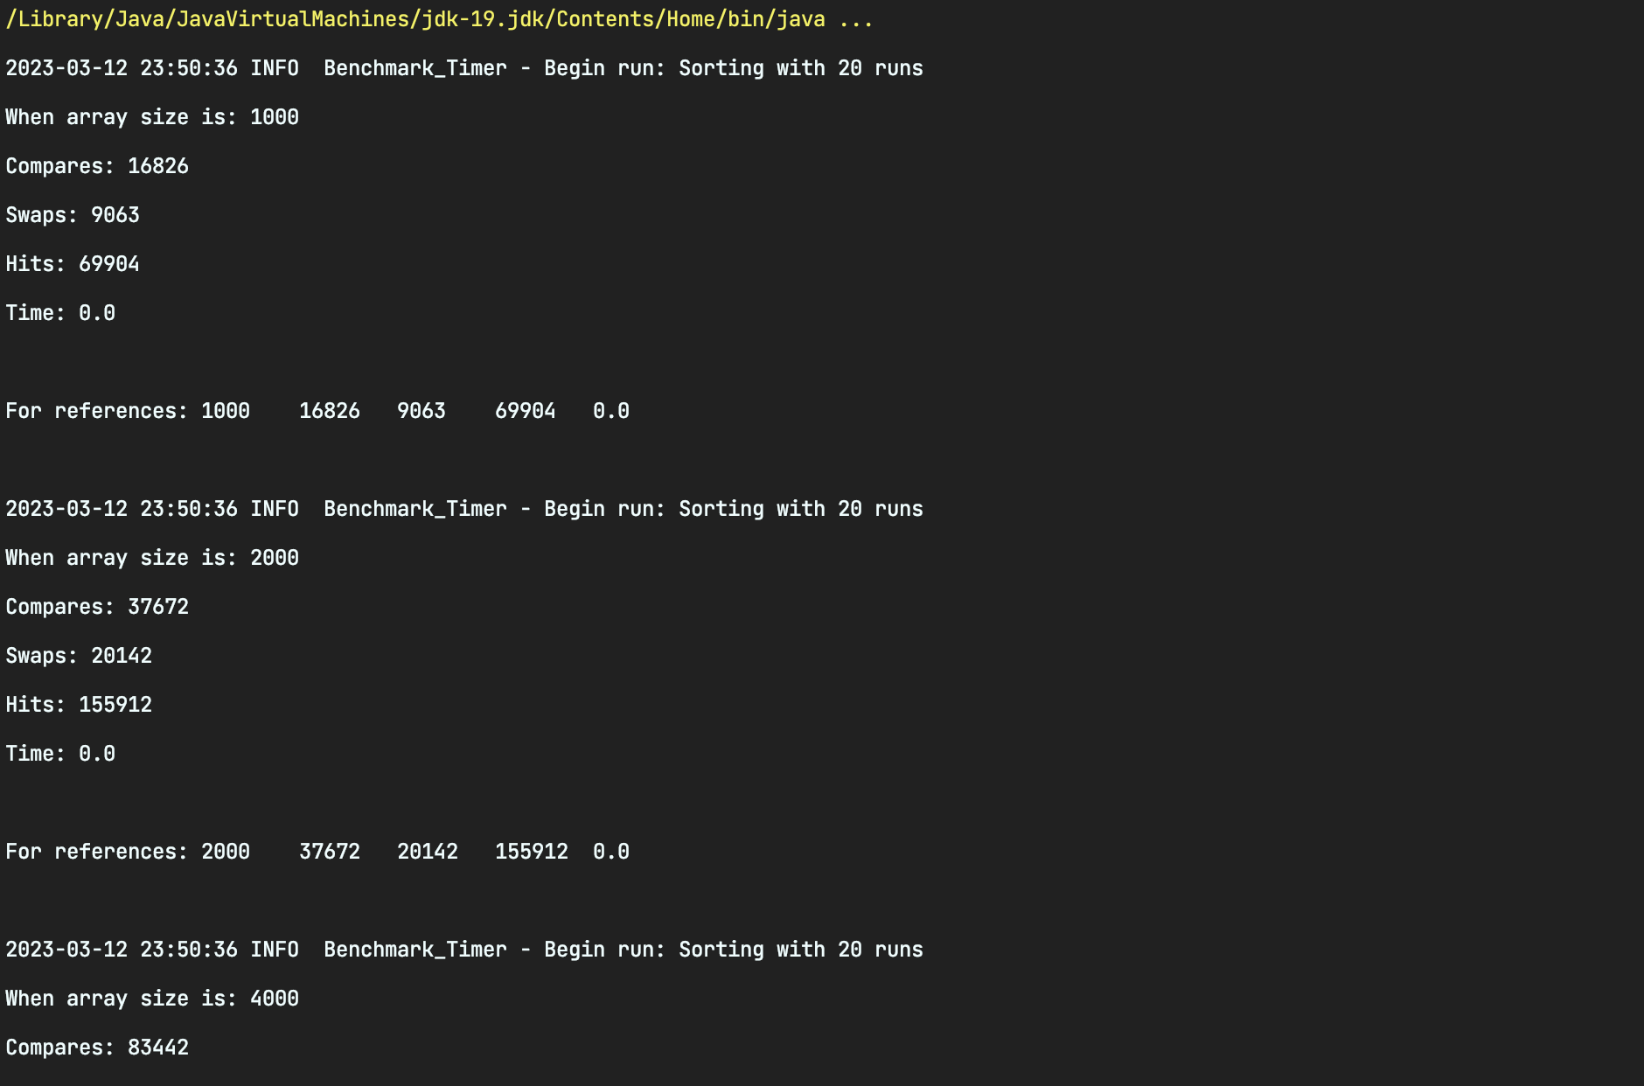

**Merge Sort**

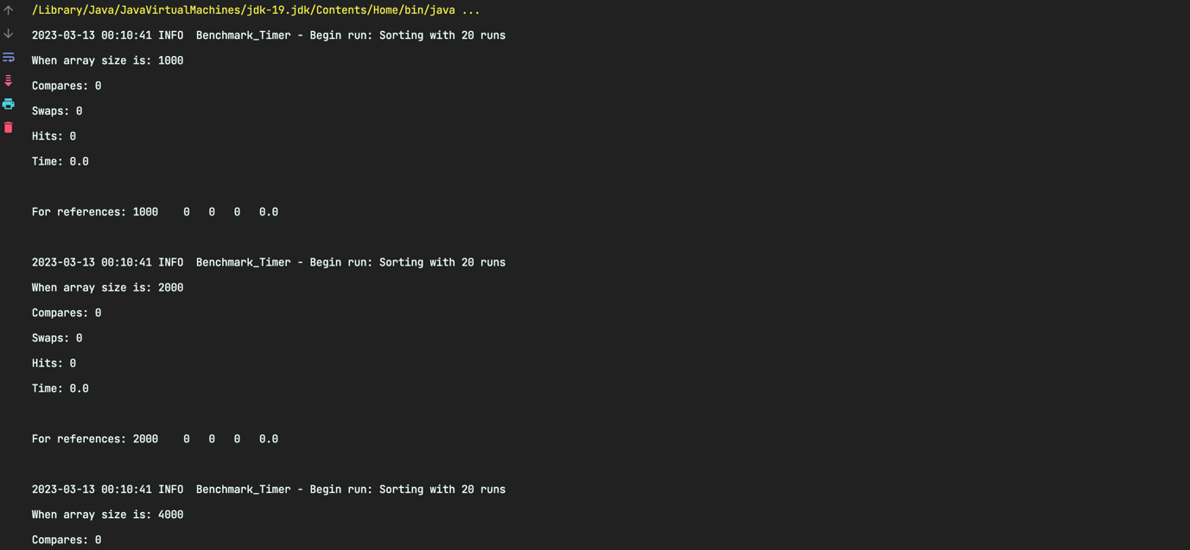



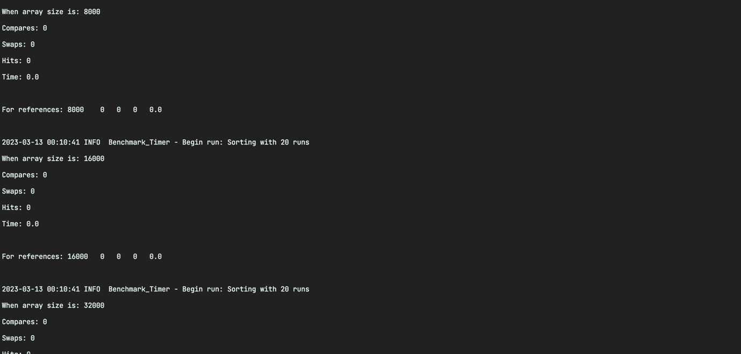

**QuickSort-DualPiivot**

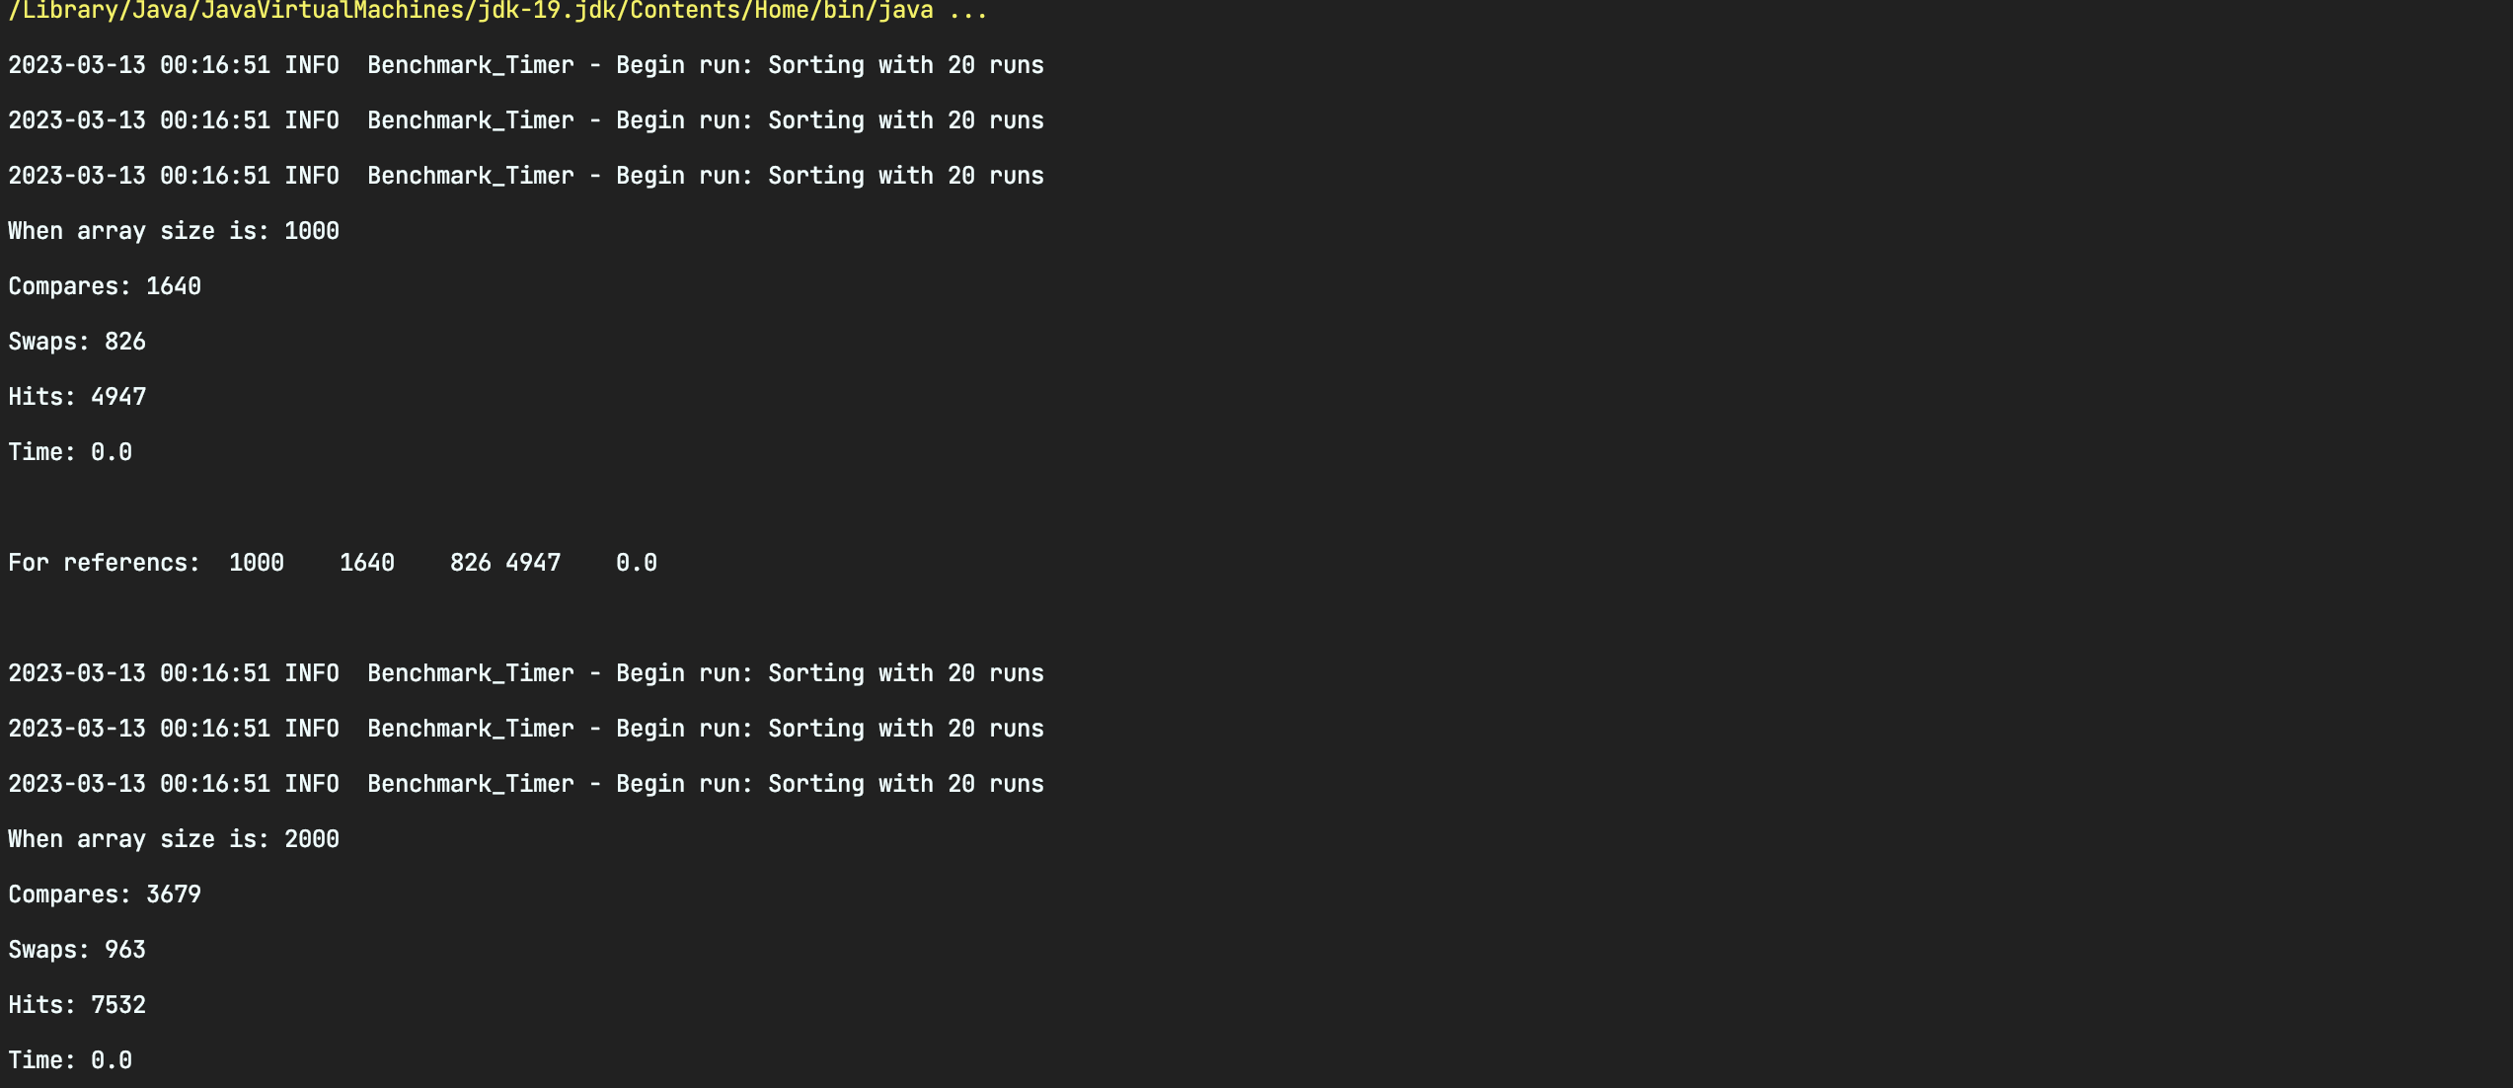

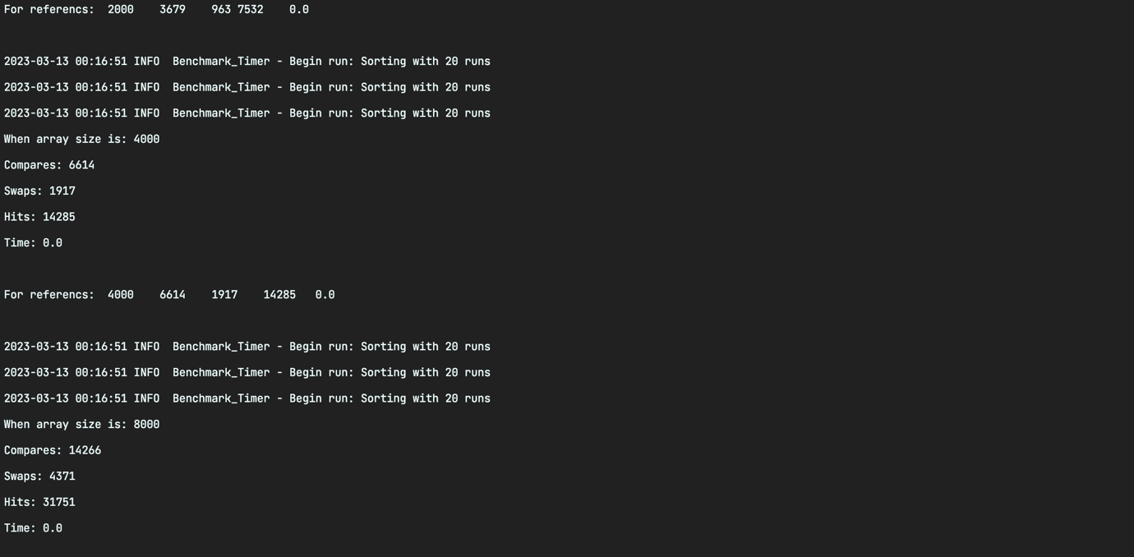

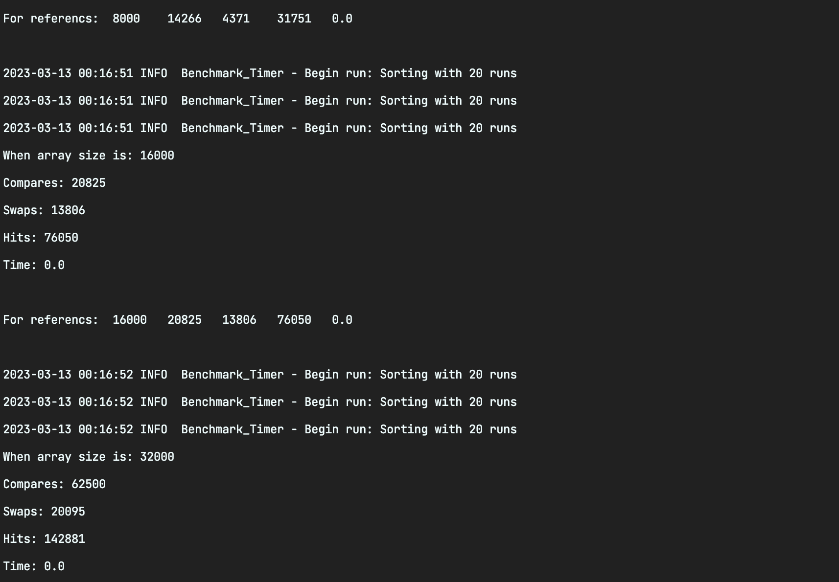

**Conclusion**

Relationship Finding: It is clear that the number of compares is the best indicator of execution time after running Merge Sort, Fast Dual Pivot Sort, and Heap Sort for different array lengths (N) and measuring the compares, swaps, and the execution time (T). Drawing Log-Log graphs for the array length (N) compared with execution time and comparisons helps demonstrate this.

It is clear from the log graphs created between the comparisons of Log N vs. Log T and Log N vs. Log that the comparison values are nearly similar to execution time (T). With respect to each of the three sorting methods, an entirely distinct graph is constructed between Log N versus Log T and Log N vs Log (Swaps). Comparisons therefore serve as the best indicator of execution time.

Graphs and values are updated on excel file which is uploaded on github